Christian Rasmussen

CSC 212

Spring Semester May 14th, 2023

Final Exam – Take-home

Part 1:

Words + Letter count (Some overlap among screenshots)

Longest word

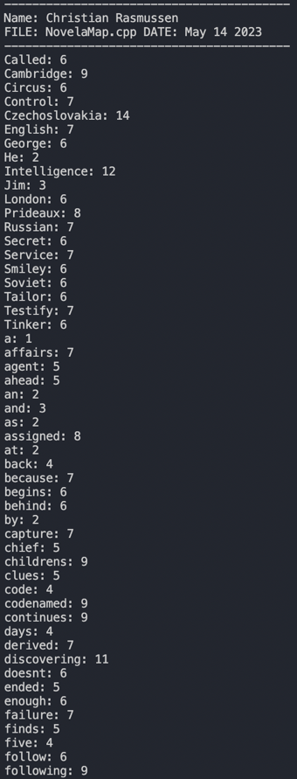

Histogram of word count frequency:

Words with less than 8 letters:

Words which start with an inputted letter (C in this case and not case sensitive)

Words that contain an inputted letter (Also C in this case)

Capitalized words:

Unique words:

Part 2:

Original order: 

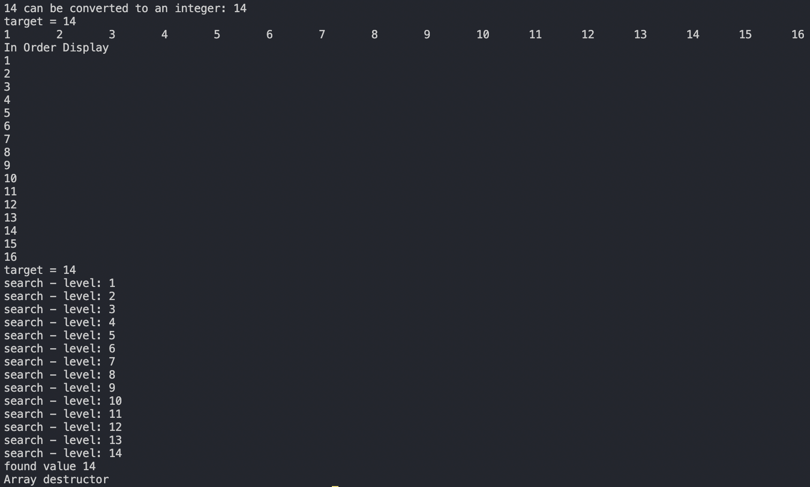

Efficient order for input: 

Float input example: 

